Assignment 1
167257

- General Hardware Database:

Salesperson:

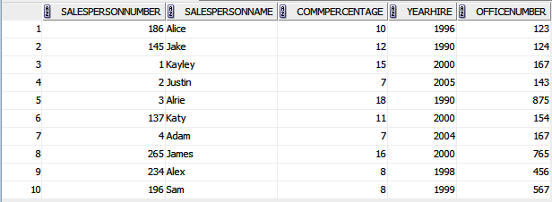

Customer:

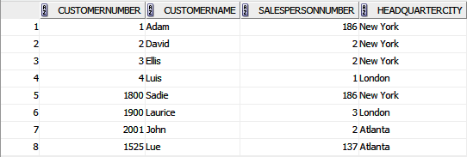

Product:

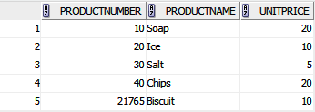

Sales:

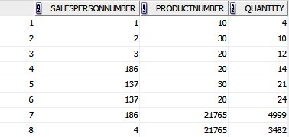

Questions:

1. Find the commission percentage and year of hire of salesperson number 186

SELECT COMMPERCENTAGE, YEARHIRE FROM salesperson WHERE salespersonnumber=186;

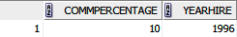

2. List the salesperson numbers and salesperson names of those salespersons who have a commission percentage of 10.

SELECT SALESPERSONNUMBER, SALESPERSONNAME FROM salesperson WHERE SALESPERSON.commpercentage=10;

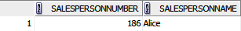

3. List the salesperson number and salesperson name of all of the salespersons.

SELECT SALESPERSONNUMBER, SALESPERSONNAME FROM salesperson;

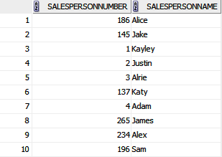

4. List the salesperson numbers, salesperson names, and commission percentages of the salespersons whose commission percentage is less than 12.

SELECT SALESPERSONNUMBER, SALESPERSONNAME, COMMPERCENTAGE FROM salesperson WHERE SALESPERSON.commpercentage<12;

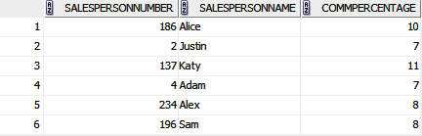

5. List the customer numbers and headquarters cities of the customers that have a customer number of at least 1700.

SELECT CUSTOMERNUMBER, HEADQUARTERCITY FROM customer WHERE CUSTOMER.customernumber>1700;

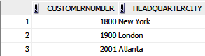

6. List the customer numbers, customer names, and headquarters cities of the customers that are headquartered in New York and that have a customer number higher than 1500.

SELECT CUSTOMERNUMBER, CUSTOMERNAME, HEADQUARTERCITY FROM customer WHERE CUSTOMER.headquartercity='New York' AND CUSTOMER.customernumber>1500;

7. ‘List the customer numbers, customer names, and headquarters cities of the customers that are headquartered in New York or that have a customer number higher than 1500.

SELECT CUSTOMERNUMBER, CUSTOMERNAME, HEADQUARTERCITY FROM customer WHERE CUSTOMER.headquartercity='New York' OR CUSTOMER.customernumber>1500;

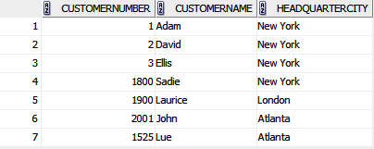

8. List the customer numbers, customer names, and headquarters cities of the customers that are headquartered in New York or that satisfy the two conditions of having a customer number higher than 1500 and being headquartered in Atlanta.

SELECT CUSTOMERNUMBER, CUSTOMERNAME, HEADQUARTERCITY FROM customer WHERE CUSTOMER.headquartercity='New York' OR (CUSTOMER.customernumber>1500 AND CUSTOMER.headquartercity='Atlanta');

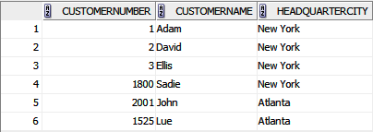

9. Which cities serve as headquarters cities for General Hardware customers?

SELECT DISTINCT(HEADQUARTERCITY) FROM CUSTOMER;

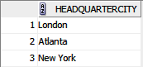

10. Find the customer numbers, customer names, and headquarters cities of those customers with customer numbers greater than 1000. List the results in alphabetic order by headquarters cities.

SELECT CUSTOMERNUMBER, HEADQUARTERCITY FROM customer WHERE CUSTOMER.customernumber>1000 ORDER BY CUSTOMER.headquartercity ASC;

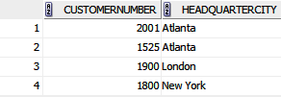

11. Find the average number of units of the different products that Salesperson 137 sold (i.e., the average of the quantity values in the first three records of the SALES table).

SELECT AVG(QUANTITY) FROM SALES WHERE salespersonnumber=137;

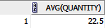

12. What is the largest number of units of Product Number 21765 that any individual salesperson has sold?

SELECT MAX(QUANTITY) FROM sales WHERE productnumber=21765;

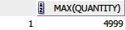

13. How many salespersons have sold Product Number 21765?

SELECT COUNT(SALESPERSONNUMBER) FROM SALES WHERE productnumber=21765;

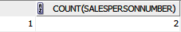

14. Find the total number of units of all products sold by each salesperson.

SELECT SALESPERSONNUMBER, SUM(QUANTITY) FROM SALES
GROUP BY salespersonnumber;

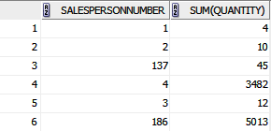

15. Find the total number of units of all products sold by each salesperson whose salesperson number is at least 150.

SELECT SALESPERSONNUMBER, SUM(QUANTITY) FROM SALES
GROUP BY salespersonnumber
HAVING salespersonnumber>150;

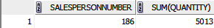

16. Find the total number of units of all products sold by each salesperson whose salesperson number is at least 150.

SELECT SALESPERSONNUMBER, SUM(QUANTITY) FROM SALES
GROUP BY salespersonnumber
HAVING salespersonnumber>150;

17. Find the total number of units of all products sold by each salesperson whose salesperson number is at least 150. Include only salespersons whose total number of units sold is at least 5000.

SELECT SALESPERSONNUMBER, SUM(QUANTITY) FROM SALES
GROUP BY salespersonnumber
HAVING (salespersonnumber>150 AND SUM(QUANTITY)>5000);

18. Find the name of the salesperson responsible for Customer Number 1525.

SELECT SALESPERSONNAME FROM salesperson, customer WHERE salesperson.salespersonnumber = customer.salespersonnumber AND customer.customernumber = 1525;

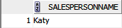

19. List the names of the products of which salesperson Adams has sold more than 2000 units.

SELECT ProductName FROM salesperson, sales, product
WHERE salesperson.salespersonname = 'Adam' AND sales.salespersonnumber = salesperson.salespersonnumber AND Product.productnumber = sales.productnumber AND sales.quantity > 2000;

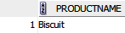

20. Which salespersons with salesperson numbers greater than 200 have the lowest commission percentage?’’ (We’ll identify salespersons by their salesperson number.)

SELECT salesperson.SALESPERSONNUMBER FROM salesperson WHERE commpercentage=(SELECT MIN(commpercentage) FROM salesperson
WHERE salespersonnumber > 200) AND salespersonnumber > 200;

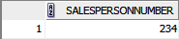

- Book Stores Database:

Publisher:

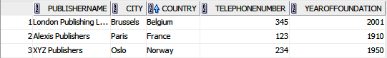

Author:

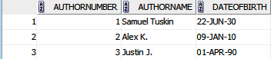

Book:

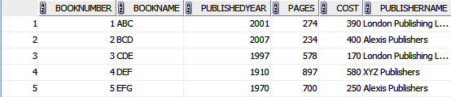

Writing:

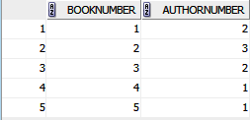

1. Find the book number, book name, and number of pages of all the books published by London Publishing Ltd. List the results in order by book name.

SELECT BookNumber, BookName, Pages FROM Book WHERE PublisherName = 'London Publishing Ltd.'
ORDER BY bookname ASC;

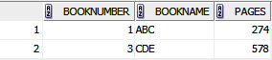

2. How many books of at least 400 pages does Good Reading Bookstores carry that were published by publishers based in Paris, France?

SELECT COUNT(BookNumber) FROM Book, Publisher WHERE pages > 400 AND book.publishername = publisher.publishername AND publisher.city = 'Paris' AND publisher.country = 'France';

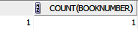

3. List the publishers in Belgium, Brazil, and Singapore that publish books written by authors who were born before 1920.

SELECT DISTINCT publisher.PublisherName FROM Publisher, Author, Writing, Book
WHERE Publisher.publishername = Book.publishername AND Book.booknumber = Writing.booknumber AND Writing.authornumber = Author.authornumber AND Author.dateofbirth < '01-JAN-1920' AND (Publisher.country = 'Belgium' OR Publisher.country = 'Brazil' OR Publisher.country = 'Singapore');

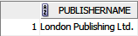

4. How many books did each publisher in Oslo, Norway; Nairobi, Kenya; and Auckland, New Zealand, publish in 2001?

SELECT publisher.publishername, COUNT(*) FROM publisher, book
WHERE (publisher.city = 'Oslo' AND publisher.country='Norway') OR (publisher.city = 'Nairobi' AND publisher.country = 'Kenya') OR (publisher.city = 'Auckland' AND publisher.country = 'New Zealand') AND book.publishername=publisher.publishername AND book.publishedyear = 2001
GROUP BY publisher.publishername;

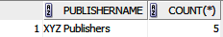

5. Which publisher published the book that has the earliest publication year among all the books that Good Reading Bookstores carries?

SELECT publisher.publishername FROM publisher, book WHERE publisher.publishername = book.publishername AND book.publishedyear = (SELECT MIN(book.publishedyear) FROM book);

